Address  
Phone

Website Adress

**Name of Club**

Club Logo

Photo

Member Information Booklet

Table of Contents



A message from the President

**Message from the President** 2

**Our Vision, Mission and Values** 3

**Club’s Profile** 4

**Committee/Board Members**  5

**Membership, Fees, Uniforms & Attire** 6

**Sponsors and Events** 9

**Codes of Behaviour**  10

**Complaints** 12

**Club Stuff** 13-15

This section should include a brief welcoming address from the club president, thanking new members for their support and a message of appreciation to existing members for their continued support.

It is also a good opportunity to provide a quick recap on the notable events of the previous year/season and any important news for the coming year/season.

**Volunteer Note e.g.** ……….. Club is run entirely through volunteer support. We ask that you respect this, thank people whenever you can and that every member is prepared to lend a hand in some way.

Our Vision, Mission and Values

Insert Mission Here

Insert Vision Here

Our Vision

Insert Clubs Values here:

* ……….
* ………..
* ………..
* ………..

Our Values

Our Mission

Club Profile Key Contacts

Insert a list of important contacts at your club and details for what reasons they should be contacted eg.

* Senior Coach/Manager for senior participation enquiries
* Junior coordinator for all underage information
* Welcoming Officer for new and existing member support
* Sponsorship Coordinator
* Bar Manager for all event/function queries.

Building your profile

This section should communicate the following information to your members:

* A brief history of the club
* Where you are located/play
* Major achievements as a club
* A breakdown of your membership demographic eg. Who you provide opportunities for (includes playing opportunities but also volunteer roles and committee positions
* How to join the club

Committee Members



**Note:**

**You can change the wording from Committee to Board should that better represents your composition**

**Also, roles are an example, they do not reflect how all clubs should structure their committee/board**

**It is important to promote committee/board members so that all club members can easily identify them**

Committee Member

Committee Member

Welcoming Officer

Junior Coordinator

Public Officer

Secretary

Treasurer

Vice President

President

Membership, Fees, Uniforms, Attire and Equipment

In this section you should outline information regarding:

**Membership**

•Categories

•Costs for each section/category

•Payment options

**Fees**

•Insurance

•League/Association registration

•Equipment

**Uniforms**

•Required uniform options for participants

•Cost of uniforms

•Order Information

•Flexible uniform policy

**Attire**

•Optional Club attire available

•Costs

**Equipment**

•Information on required equipment

•Recommended purchase outlet

• **E.g. Mouthguards are compulsory**

Medical Information & Insurance details



Make a statement in this section that the club will require a copy of participants medical history on registration day or prior to the commencement of their participation.

**Note:**

**A sample medical history form is available for you to download on Club Help.**

Inform members that injures are recorded and kept for a period of 7 years

It is important to advise members what Insurance policy the club has and what, if any coverage they have as part of their membership costs. This will allow participants to make informed decisions prior to participation regarding personal health insurance/private health.

**Ambulance Cover**

Please be aware that in the event of an emergency or serious injury, an ambulance will be called. Members or guardians in the case of minors will bear the cost of this transport. **It is therefore recommended that all members have ambulance cover.**

Competition Fixtures & Events

• Age groups and cut off dates for age groups

• Training days, times and venue for each age group and section

• Competition Dates, Days and times - **fixtures are available www…….**

• Insert major sponsor logos and minor supporters by listing them

• Message about supporting sponsors wherever possible

Sponsors

**E.g.**

• Annual General Meeting

• Major Fundraiser

• Sponsor Day

• Presentation Day

Events

*Example– On registration you or your guardian signed that you would adhere to the*

*following*

All players, members, spectators, officials and volunteers are expected to follow our

Club’s codes. Failure to do so will result in disciplinary action.

***COACHES*** are required to:

* Respect the rights, dignity and worth of every person regardless of their gender, ability, cultural background or religion
* Support, encourage and involve all players regardless of their talent level
* Never ridicule or yell at players for errors or poor performance
* Always consider the wellbeing and safety of participants before performance and results
* Encourage participants to value their performances and not just results
* Encourage and guide participants to accept responsibility for their own performance and behavior both on and off the field
* Maintain respectful and appropriate relationships with all participants
* Ensure all activities are appropriate to the age, ability and experience of participants
* Promote the positive aspects of the sport (eg fair play)
* Always respect the official’s decision and support them to carry out their role
* Display consistently high standards of good sporting behaviour and appearance
* Follow all guidelines laid down by the national governing body and the Club
* Hold appropriate valid qualifications before commencing to coach
* Never condone rule violations, unfair or unduly rough play or the use of prohibited substances
* Never smoke or drink alcohol whist in an official capacity
* Never use offensive language or behavior
* To act as a role model at all times.

Club Code of Conduct

Club Code of Conduct

***PLAYERS*** *are required to:*

* Respect the rights, dignity and worth of every person regardless of their gender, ability, cultural background or religion
* Play by the rules and respect the umpire’s decisions
* Display good sporting behavior at all times
* Never use offensive language or behavior towards anyone or engage in sledging or bullying of any person
* Co-operate with your coach
* Adhere to club policies including smoke-free areas and liquor license requirements
* Never behave in a manner that would damage the reputation of the club either on or off the field

***VOLUNTEERS and SPECTATORS*** *are required to:*

* Act as good role models and ambassadors for the club at all times
* Always welcome opposition players, spectators, officials etc to the club
* Never use offensive language or behavior
* Treat everyone including the opposition with respect regardless of their gender, ability, cultural background or religion
* Display consistently high standards of good sporting behavior including respecting the official’s decisions
* Adhere to the smoke-free policies of the club
* Not to consume alcohol in any place other than where the club’s license allows
* Adhere to and support the Club policies
* Be trustworthy

Problems or Complaints

* If you have a problem or complaint who to go to and what to do
* Some detail about the complaints procedure
* A note e.g. remember when considering a complaint that the Club is staffed by volunteers who are giving up their time
* Note e.g. it is expected that complaints are made away from training or game day

The Year in Photos (insert photos that celebrate your club)

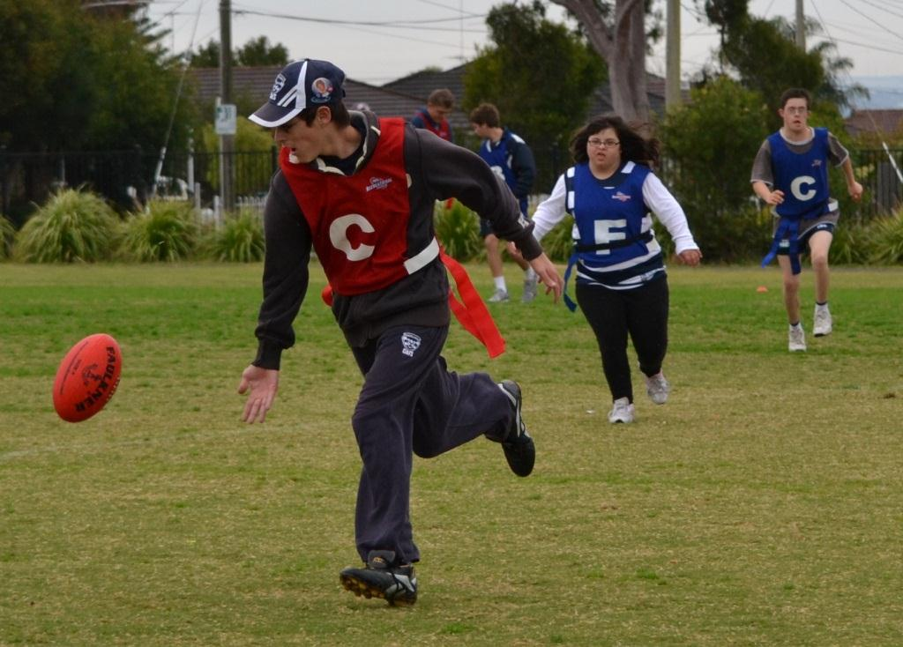

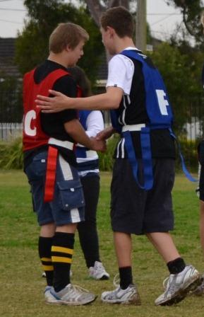

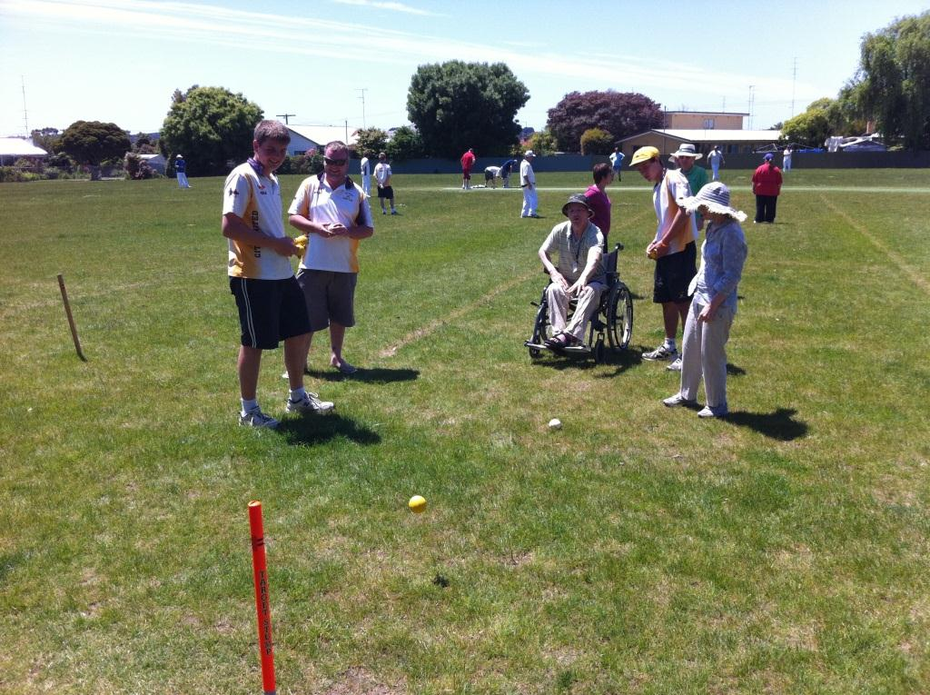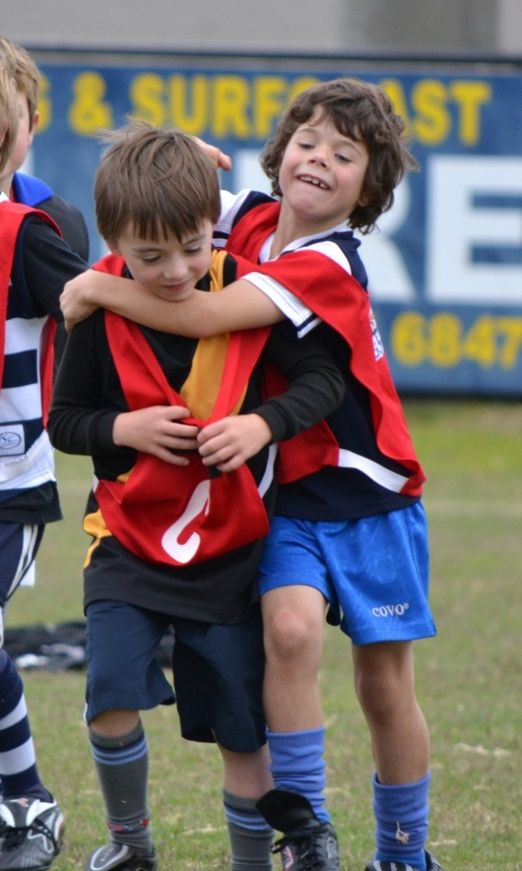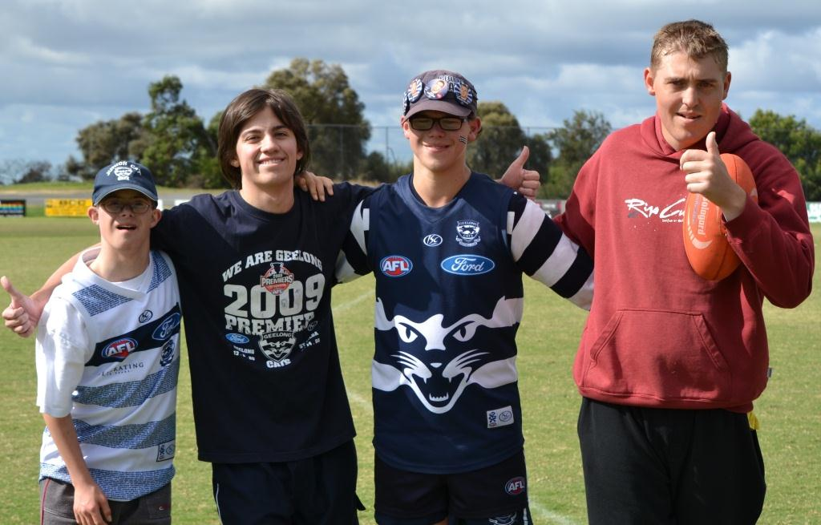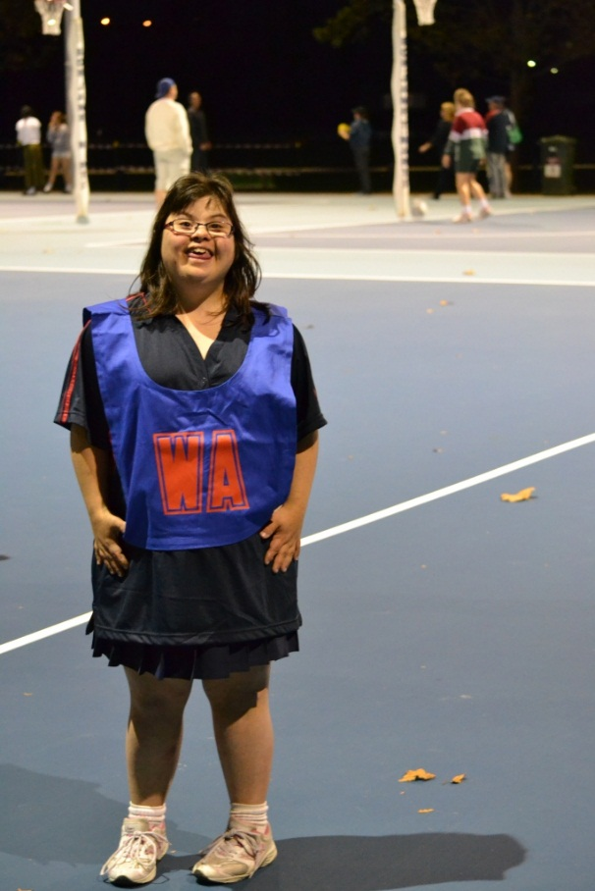

Club Song

We are the Navy Blues…

And they will know that they’ve been playing  
Against the famous old dark Blues

**Insert sponsor logos**

[](http://www.adf.org.au/)

**Full contact details**